Writing Strategy:
3-2-8 Paragraph
First sentence has 3 ideas in it. Each one of those three ideas gets two sentences. The eighth sentences wraps it up and restates the first sentence in a summarization.
Example:
For my dog TJ’s 11th birthday she went to Fleabuck’s¹, Boneanza ², and Barkin’ Robbins Ice Cream ³. At Fleabuck’s she had a nice bowl of iced water. She asked for a sprig of mint in her water and splashed the mint so she had minty fresh breath. ¹ We then trotted over to Boneanza for a nice juicy T-bone steak. TJ loves to gnaw the bone so she quickly ate the steak and took the bone home in a “doggie” bag. ² We then went to Barkin’ Robbins for some ice cream as a birthday treat. TJ chose Backyard Bones Bubble Yum triple dip ice cream in a cup for her birthday dessert. ³ TJ’s eleventh birthday was a real treat at Fleabucks, Boneanza, and Barkin’ Robbins.

I’ve used 3-2-8 with high school students and I’ve used it in Kindergarten with parent volunteers who served as secretaries as the students dictated the stories to them once a week.
While some people might prefer a relationship with people, I prefer my friendships with my lumbering 201 pound English Mastiff, my persnickety aging calico cat, and my brilliant saltwater Clownfish. Brutus, my English Mastiff still thinks he is a puppy and tries to sit on my lap when I sit down at my computer. Many times when I take him for a walk, people who are coming toward us are quite afraid of him because of his size being double that of the person walking him. Cleopatra, my aging calico cat has a mind of her own and is not easily swayed in her pursuits toward remaining solitary. She does manage to show up whenever she hears a can-opener and can move at lightning speed if the can happens to be of the tuna fish variety. Although it is an expensive hobby, I enjoy a saltwater tank filled with colorful reef fish including my favorite, the Clownfish. My Clownfish are brilliant because they will follow my finger as I trace it back and forth across the side of the tank when it is time to feed them. People can let you down, but my faithful sidekick Brutus, my finicky old cat Cleopatra and my gifted Clownfish never let me down because they entertain me and make me smile.

I learned about this technique when I was taking classes at UNC Charlotte in North Carolina. I do not know who to credit with the idea, but I have had countless students tell me that this really helps them stay on topic to use the 3-2-8 paragraph formation.

The first sentence has three ideas in it.
The writer then writes two sentences about each of those ideas.
The final sentence summarizes the whole paragraph by mentioning all three ideas.

When tied with John Morris’ Three Stars and Wish, the students can get better and better with their writing by adding more detail to their paragraphs.

Three Stars and a Wish
By John Morris in Haversham, England (Ardleigh Green Junior School)
Student turns in work
Teacher writes three things that are good about the paper
Teacher writes one thing he/she wishes the student would work on to improve the paper
Student rewrites the paper and then turns it in again for the same process.
Teacher can teach so many things with the same piece of writing. (Adjectives, adverbs, compound sentences, spelling, punctuation, and more)
Student has a quality piece of work when finished.

Three Stars and a Wish
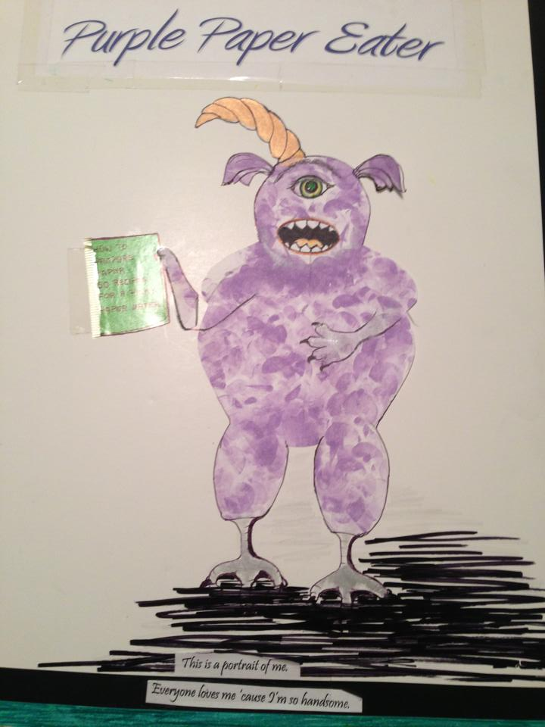
By Monika Marcel in Houma, LA
Same idea- but it is graded by the purple paper eater (pretend monster). She grades it in a purple pen for her three stars and a wish and then slimes the edge with a little purple glitter eye shadow. The kids can’t wait for the Purple Paper Eater to grade their papers.

