HELP!!!! My students aren’t working when directed.
 | Trigger | Target | impacT
 | The triggers could be varied; however, most emails appear to be when work is assigned. | Blurting  Talking out of Turn  Non-compliance (off task) | Access to preferred activity  Attention to/from Peers
 | Revise the Environment | Replace the Behavior | Reframe the Response
Universally
TUMS | Staff stands at door and greets students using TUMS: Touch them (high five)- Use their name in a positive way- Make eye contact- Smile  Teachers who greet their students at the door enjoy less disruptions (approximately 45-72% less)  (Allday & Pakurar, 2007, Cook et. al, 2018) | Any student who needs a behavior plan should have a secret signal at the door with the teacher that reminds them of their behavior plan (save face- use secret code)-example tugging on your ear means remember to use your listening ears. Tap on your shoulder means – keep hands and feet to self. These are things you share in private with the student and they become part of the handshake as a cue to remember the behavior you are targeting.  The replacement behavior might have been sent home with a video model, video self-model, or social story about engaging in the appropriate behavior. | Give behavior specific praise for any approximation of the appropriate behavior.  Ignore low level behaviors (especially those that appear to be for teacher attention)  Immediately give attention once the student is on task

 | Revise the Environment | Replace the Behavior | Reframe the Response
Universally
Group Contingency  Group Reinforcement | Mnemonic cue in the environment to remind the students what you are targeting. Example: Mr. Potato Head. When I’m teaching today, if everyone remembers to raise their hand and wait to be called on when I raise my hand for questions, I will add a piece to Mr. Potato Head. When he’s got all his parts, you will earn a reinforcer.  (ERIC has 109 research articles on group contingency effectiveness in the last five years).  A group contingency/group reinforcement is where everyone is working together to earn a class reinforcer. | Show video of appropriate behavior to all students. This way they can visualize what you are working on in the classroom. This is called video modeling. (You might have brought 5-8 students in to model the behavior on tape and make an appropriate video).  You have to TIPP the behavior (Teach it- Imprint it by modeling it- Practice it with the students and Praise it when you see it occurring) | This is so important: If you want your students to follow directions, you must be consistent. Sometimes we accept blurted answers etc.  This is perceived as injustice by those that have received scorn for blurting. If you want them to raise their hand, you must raise your hand. This will help you remember to only listen to, respond, and call on people who have their hands up. If you want everyone to blurt out the answer, sweep your hands out toward the class. This lets them know and reminds you that everyone can blurt out the answer.  They earn Mr. Potato Head pieces when they follow the directions.

 | Revise the Environment | Replace the Behavior | Reframe the Response
Universally
Expectations | Clearly defined expectations should be posted in the room. The limit should be no more than five. These are general expectations that are positively stated and easy to remember.  (www.pbis.org) | Examples of what each expectation looks like, sounds like, and feels like should be TIPPed for every classroom/school area. Example: This is what being respectful looks like in the restroom, hallway, playground, commons area etc.  These can be taught with video modeling, video self-modeling, relationship narratives etc. | Give behavior specific praise. Reteach when necessary for students who don’t follow the expectations. Remember, you can improve 80% of the classroom behavior by labeling the appropriate behavior.

 | Revise the Environment | Replace the Behavior | Reframe the Response
Targeted
ADHD Students | Provide flexible seating opportunities. This allows for more proprioceptive input. Movement helps students engage their brains and bodies together.  Provide fidget tools if appropriate. (I really like non-skid bathtub appliques applied under the desk or table. This is age appropriate for all students and they last and can’t be thrown or used inappropriately. Most dollar stores have 12 in a package for $1.  Provide foot fidgets if necessary/appropriate. Adults move their legs to help them pay attention during meetings. We just need to teach this skill to students.  Remove all visual distractions. This might be messy desks, open storage that is not neatly organized, too many posters on the wall- etc. | Teach students how to stay on task. A personal anchor sheet for what to do when I feel myself starting to lose focus might be helpful.  Use anchor sheets, video models, video self-modeling, relationship narratives, calming cards etc. | Tie them into the group contingency/group reinforcement. Here’s an example: Let’s say Shawn has ADHD and is prone to daydreaming and fidgeting inappropriately. Work out a secret code with Shawn that if you say “I SPY someone …” whatever you say next is what you need Shawn to be doing. You’ll have to role play in private meetings. Later when Shawn is about to lose his focus- look at someone who is behaving appropriately and say “I spy someone sitting up straight and tall and really paying attention. You just earned the class a point.” The words “I spy” were secret code to Shawn. In a few minutes when Shawn has gotten the message, look at Shawn and say, “I spy someone sitting up straight and tall and really paying attention. You just earned the class a point.” This is great public relations for the student and really helps them learn the replacement behavior.

 | Revise the Environment | Replace the Behavior | Reframe the Response
Targeted
Learning Difficulties (Academic or Social) | Check-in/Check-out (CICO). Have the student go directly to a preferred adult first thing in the morning. Have this person pre-teach them the anticipatory set of the daily lesson or review the social cues necessary. They will check out with the student at the end of the day to help them process.  Use the STARS teacher/student rating sheet (see attached). This will help the student and the CICO person to process the growth. | The student might watch a video of the upcoming lesson, learn a secret mnemonic tool, or learn a cool fact to share with the class in the CICO room.  The CICO person will also work on ways to help the student be more comfortable asking for help. Perhaps using a secret cue when they need help. I had a student that would turn his name plate over if he needed help- this was my cue and no one else knew what that meant. | Use secret cues to let the student know you appreciate the efforts they are making. If they start to revert to old behaviors, use secret cues to help them remember the replacement behavior.  Saving face is very important for students who struggle with learning difficulties. Helping them save face stops a lot of behavior.
Oppositional Students | Provide similar worksheets that cover the same material, so student has a choice in compliance. (Keeps the synapses firing in the prefrontal cortex). | Teach student how to ask for help. Sometimes students behave improperly because they would rather be known as the class potty mouth than the student who needs help with a subject. Together develop a way to ask for help that only you and the student know.  Teach the student that you won’t call on them in class unless they show you they know the answer (they raise their left hand if they know the answer- that’s the secret clue) | Use equal choices offered from the student’s right side. (50 years of right side preference research)

 | Revise the Environment | Replace the Behavior | Reframe the Response
Intensive
Functional Behavior Assessment | For students who fail to thrive with the universal and targeted interventions, it will be necessary to conduct a functional behavior assessment. We need to determine the function of the behavior and the triggers that set the behavior in motion. | First, we need to define the behavior we are targeting for change. Then we need to define the replacement behavior we want to see.  This needs to be in measurable and observable terms. We can use video modeling, peer mentoring, video self-modeling, peer tutoring, role playing, relationship narratives, point of view video modeling etc. to help the student learn the replacement behavior. | Once we know the function of the behavior, we reinforce the replacement behavior with that consequence (impacT) and withhold the impacT from the targeted behavior.  The only way to document the function of the behavior is to collect data. A fifteen-minute observation is not a functional behavior assessment. We like 10 days of data because it gives you two samples of each day of the week. We find that some students are triggered by days of the week.

STARS
The following pages on Student Teacher Action Rating Sheets (STARS) have been very effective for many teachers. It is not enough to tell children to “be respectful”, we must teach them what that looks like, sounds like, and feels like. Just as an 87% on a paper does not teach a child what they did correctly and what they did incorrectly; telling a child to flip a card to another color does not teach them to see their behavior the same way the adult sees their behavior.

The following pages are a self-management tool for teachers to use with children who are having a difficult time with universal classroom management techniques.
The teacher grades their behavior on a few positively stated expectations every hour using a scale of 3-2-1 (3 means everything went extremely well that hour, 2 means things went well but could have been a little better, and 1 means things could have been better). I do not believe in using a zero or a sad face with a child because children equate this with “I’m a zero. I’m not worth anything.” (As soon as a child believes this about themselves they will begin to act as if they are a zero or not worth anything and that is not where we want any child’s self-worth to rest.)
I actually was doing a training once and a lady raised her hand and said, “Get real. Some children are zeros.” I sincerely hope this woman has found work in another industry, because if you believe that children are not worth anything, you should not be in charge of their education.
The child grades their behavior on the same scale of 3-2-1. They can do this on the sheet of paper provided on the next pages or on a separate piece of paper. The child should not be able to see what the teacher wrote and the teacher should not be able to see what the child wrote. When they put their two papers together, if they match the child gets that number of points. 3+3= 3 points, 2+2= 2 points and 1+1= 1 point. If the teacher marks the child a 3 and the child marks their behavior a 2 then no points are earned. This helps the child learn to see their behavior the same way the adult sees their behavior. We usually laminate the student’s copy and then they can use it again and again.

Most children really buy into this program because it is competition and they love competition. My favorite way to “pay off” on this program is to have the child choose a menu of point accumulation and the reward occurs at home. For example, if a child had six hours with 9 points possible for each hour their top point accumulation would be 54 points. The menu might look like this:
- 1-25 points= 5 extra minutes of computer game at home
- 26-35 points = 10 extra minutes of computer game at home
- 36-40 points = getting to choose what the family eats for dinner that night
- 41-50 points = getting to help parent cook the dinner that the family eats for dinner
- 51-54 points = getting to choose the family movie to watch that night
For older students substitute smiley faces with the numbers 3-2-1. Students must earn the number of points they were given. If they only earn one point for matching, the child will quickly figure out that if they have tons of targeted behaviors the teacher will mark them a “one” and then the student can mark a “one” and they will match. Smart kids! (I learned this lesson the hard way.)

The teacher marks the score for each section where the student cannot see what the teacher is writing. The student marks the score for each section where the teacher cannot see what the student is writing. The student and teacher then get together and everywhere they match the student earns points.

You’ll have to come up with the menu based on his/her “float the boaters”

If you involve the bus driver- just give the bus driver three cards with a number 3, 2, and 1 on separate cards. The bus driver will hand one of the numbers to the person who checks in with the buses in the morning. The bus check in person will take the card into the school and hand it to the check-in/check-out person who is monitoring the forms for the student. This way the bus driver can be involved and not take up too much of their time. The bus driver will be given the number back at the afternoon route time.

The following page has a sheet filled out.

Student Teacher Action Rating Sheet (STARS)
Student Name: _____ Sample ________________________ Date: ____________________________
 | Hour One |  |  | Hour Two |  |  | Hour Three |  |  | Hour Four |  |  | Hour Five |  |  | Hour Six |  |  | Hour Seven
Keep hands and feet to self | T | S |  | T | S |  | T | S |  | T | S |  | T | S |  | T | S |  | T | S
 | 3 | 3 |  | 2 | 2 |  | 2 | 3 |  | 3 | 3 |  | 2 | 2 |  | 1 | 1 |  | 3 | 3
Stay in your assigned area | T | S |  | T | S |  | T | S |  | T | S |  | T | S |  | T | S |  | T | S
 | 2 | 3 |  | 1 | 1 |  | 2 | 2 |  | 3 | 3 |  | 1 | 3 |  | 2 | 2 |  | 3 | 3
Start work within two min. | T | S |  | T | S |  | T | S |  | T | S |  | T | S |  | T | S |  | T | S
 | 3 | 3 |  | 3 | 3 |  | 2 | 3 |  | 3 | 3 |  | 3 | 3 |  | 1 | 3 |  | 3 | 3
Accepts Score  (Teacher only) | 2 |  |  | 3 |  |  | 2 |  |  | 2 |  |  | 2 |  |  | 3 |  |  | 3
Total | 8 |  |  | 9 |  |  | 4 |  |  | 11 |  |  | 7 |  |  | 6 |  |  | 12
3= beautiful hour, 2= pretty good hour, 1= this hour could have been a lot better
Smiley faces (Great big smiley face = 3, Medium smiley face = 2, Half smiley face = 1)
Total Points Earned Today: _____57_________out of 84 possible
Reinforcement Earned: ________________________________________________________
Parent Signature: _____________________________________________________
Reinforcement for 67-84= __________________Get to have a friend over for dinner_____
Reinforcement for 58-66=___________Get to sit in Dad’s chair to watch TV___________
Reinforcement for 50-57=________________Choose what mom fixes for dinner________
Reinforcement for 49 or lower=________Get to skip a chore for the night_____________

We like the parents to reinforce at home for excellent behavior at school. We know some parents are unable to do this due to work schedules, so the reinforcement can occur at the end of the day. Young children cannot wait till Friday to be reinforced for good behavior. We have witnessed many failed behavior plans because the “pay-off” was too far in the future for the individual. Each of us has our own rate of reinforcement need. The same is true with our students. We once worked with a school that reinforced behavior four times per year, once every 9 weeks. Their behavior never improved because it was too far in the future for middle school students. In Positive Behavioral Interventions and Supports, we like the menu of reinforcers to have choices that are 2 points and choices that are 50 points. Some students can wait and others need immediate reinforcement.

The next page has one filled out for a young child with smiley faces. The child colors in the face they think that corresponded to their behavior and then the teacher puts the score for the face on her sheet.

Student Teacher Action Rating Sheet (STARS)
Student Name: _____ Sample ________________________ Date: ____________________________
Behaviors | Hour One |  | Hour Two |  | Hour Three |  | Hour Four |  | Hour Five |  | Hour Six |  | Hour Seven
3= beautiful hour, 2= pretty good hour, 1= this hour could have been a lot better
Smiley faces (Great big smiley face = 3, Medium smiley face = 2, Half smiley face = 1)
Total Points Earned Today: ______________out of 84 possible
Reinforcement Earned: __________________________________________
Parent Signature: _____________________________________________________
Reinforcement for 67-84= _______________________________________________________
Reinforcement for 58-66=________________________________________________________
Reinforcement for 50-57=_________________________________________________________
Reinforcement for 49 or lower=____________________________________________________

Parent report to school

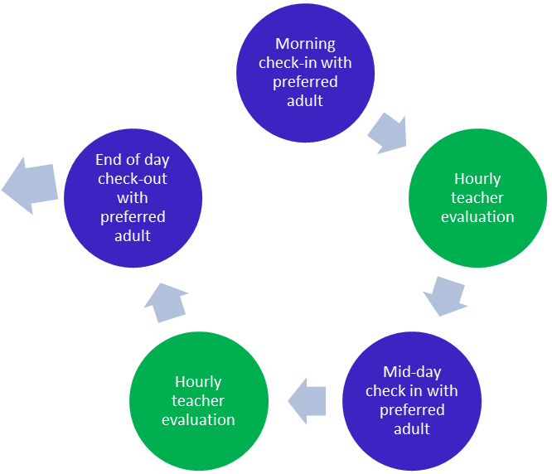
Go over daily graphed points working towards
Home check-in
Earned reinforcer
Graph points

Adapted from Hawken 2008

Free or Inexpensive Rewards for Parents to Use with Their Children

Young Children
- Assist the parent with a household chore
- Send an email to a relative telling them what a good job they had done on a project at school. In other words, email Aunt Linda and tell her about the “A” you got on your spelling test.
- Get to decorate paper placemats for the dining room table for dinner that evening
- Get to choose what is fixed for dinner that night- example: “You get to choose, I can make tacos or meatloaf. Which do you want me to fix?”
- Get to help parent fix dinner- shell peas, peel potatoes, make art out of vegetables, make ants on a log etc.
- Get to be the first person to share 3 stars and a wish at the dinner table (3 good things that happened that day and one thing they wish had gone better.)
- Get to create a family night activity- roller skating, hiking in the park, picnic dinner on the living room floor or under the dining room table with blankets over the top.
- Camp out in the backyard with a parent.
- Get a car ride to or from school instead of the bus
- Get to have a picture framed for mom or dad’s office
- Get to choose the game the family plays together that night
- Get to choose the story the family reads out loud together (read the classics)
- Get to go with a parent to volunteer at a retirement home (the children will get tons of attention)
- Get to gather old toys and take to a shelter for children who have nothing
- Get to ask friends to bring dog and cat food to their birthday party instead of toys that will break. Take the food to a shelter the day after as a reward. They will get a ton of attention from the staff.
- Bury treasures in a sandbox for the child to find. Put letters in plastic Easter eggs and they have to put the letters together that spell treat the child will receive. (ideas: a walk with grandma, bike riding at the park, etc.)
- Make special mud pies in the backyard with mom or dad or have a family contest to see who can make the best mud pie.
- Dig shapes in the sandbox and then decorate with items found around the house. Pour inexpensive plaster of paris into the shape and wait to dry. When it’s pulled out it will be a sandy relief that can be hung on the wall (if you remember to put a paper clip in the plaster of paris on the top before it dries )
- Get to go shopping with a parent as an only child. Give them a special task to look for something that you are seeking. For example: “Here’s a picture of a blue blouse that I’m trying to find. Help me look for something that looks like this.”
- Take all the children to grandma and grandpa’s except one and let that child stay home with mom and dad and be “only child” for the weekend. The other children will get spoiled with lots of attention by grandma and grandpa and the “only child” will get lots of attention from mom and dad. (If you don’t have grandma and grandpa nearby- trade with another family taking turns to keep each other’s children.)
- Download a fun recipe and let your child help you make that recipe as a surprise for the rest of the family that evening. (put up signs that say “Secret Cooking in Progress”. Must have special pass to enter the kitchen.
- Surprise your child with a scavenger hunt around the house. If they read, give them written clues hinting as to where the next card is hiding. At the end have them find a note that tells them their big prize. (If your child can’t read, you can use pictures.)
- Make a story on the computer with your child using Microsoft’s PowerPoint program. Let your child be the star of the story.
- Let your child take the digital camera out in the back yard and then come back in and turn those pictures into a story on the computer. Help them print off their book for a distant family member.
- Go outside and collect cool leaves and flowers. Come inside and put those leaves and flowers between two sheets of wax paper. The parent will iron these two sheets together and create placemats for everyone in the family for the evening.
- Start a family story at the dinner table and each person in the family has to tell a part of the story. The child being rewarded gets to start and end the story.
- Let your child earn 5 minutes of either staying up later or sleeping in the morning. Use that time to read together if they stay up later.
- Play secretary and let your child dictate a story to you. Type up the story and send it out to some relatives who will call them and tell them how much they liked the story.
- Write a story for your child where the child or their personal hero is a character in the story.
- Change the screen saver on your computer to say “My child is the greatest.” …or something that would make them feel good about themselves. Do this at your office and then take a picture of it or take your child to your office on the weekend and let them see it.
- Let your child help you do the laundry and then pay them with a special dessert for dinner. Be sure to say, “Since you helped me save time by helping me fold the laundry, I have time to make this special dessert for dinner.”
- Help your child organize their room giving them a mnemonic to help them remember where things go- for instance teach them the color order of the rainbow and then teach them to hang up their clothes in color groups matching the order of the rainbow (ROYGBIV). Later on when you catch them hanging up their clothes in the correct place draw a “rainbow” award for their good work and put it on their door as a surprise when they come home.
- Have the bedroom fairy come while they are at school and choose the bedroom that is the neatest. Hang a fairy from the doorway of the room that is the neatest and that person gets to sit in “Dad’s chair” to read that night. (or something that would be appropriate at your house).
- Mystery grab bag. Take an old pillow case and put slips of paper inside listing some of the prizes on this page and let the child draw out the prize they are going to get for their behavior reward.
- Let your child dictate where you drive on the way home from a location. In other words, they have to tell you turn left here…turn right here. If they happen to steer you into a Baskin Robbins Ice Cream Parlor, it wouldn’t be a horrible thing to stop and have a family treat together.
- Give your child a special piece of jewelry that belongs to you to keep and wear for the day. (Nothing that costs a lot of money- but something that looks like it is special to you.) The child will feel special all day long.
- Take your children to the library one at a time and give them special one on one time at the library checking out books or listening to stories.
- Sign your child up for acting lessons (they have to have earned this privilege). Many universities offer free acting classes on the weekend for children.
- Take your child to an art gallery and then have them draw a picture of their favorite painting or statue. Possibly stage a mini art gallery tour of the child’s work for relatives who are coming to visit. Serve cheese and grape juice.
- Take your child to the university astronomy lab. (It is usually free). Help them place stars on the ceiling of their room in their favorite constellation. If possible they could paint the stars with “glow in the dark” paint.
- Take your child on a nature walk and collect rocks. Bring the rocks back home and have a contest painting the rocks to look like animals.
- Have your child collect some toys they have outgrown. Clean up the toys and take them to a local hospital children’s ward and donate the toys to the ward. The child will get lots of attention and feel good.
- Go to your local appliance store and ask them to save a refrigerator box for you. The next time your child earns a reward, give them the box and help them plan and decorate the box to turn it into anything their imagination desires.
- Make Papier-mâché Halloween masks by taking punch ball balloons and spreading the paper strips over the balloon shape. Make noses, horns, tongues whatever they desire and then paint when dry. You will have a unique and free Halloween costume and you will have given your child tons of attention.
- Find an old fashioned popcorn popper (not an air popper). Spread an old sheet out on the living room floor, put a little oil in the popper and then have your children sit outside the perimeter of the sheet. Put a few kernels of popcorn in the popper and watch them fly up in the air. The children will love watching this. For a special treat pour cinnamon sugar on the popcorn after it pops.
- Find some light balsa wood and create a boat powered by a rubber band and paper clip paddle wheel. Make a unique sail and take the boat to a creek or lake nearby and help your child launch their boat. Be sure to take a butterfly net to retrieve the boat when it goes downstream. (Proactively, you could put an eye hook on the front of the boat and attach some fishing line to it so it can be brought back to shore.
- Take your child fishing. It’s a great place to have some really in depth conversations.
- Take your child for a ride looking for items that start with each letter of the alphabet. Take the child’s picture in front of each item that starts with that letter and then put it together as an ABC Book. For example: “This is Johnny in front of Applebees.” “This is Johnny in front of BlockBuster.” And so on….
- Check with your local humane society and see if they allow children under 18 to volunteer to feed and water the animals. (Some shelters only allow adults over 18). Let your child earn the privilege of going to the shelter to feed and water the animals. Perhaps they can walk a small dog or pet a cat.
- Take your child to the local fire department. As long as they are not busy, they will be glad to show the child around and give them some great attention. Most children have seen a fire truck, but few have actually gone to the fire department to see what it looks like.
- Play the “Gatekeeper Game” with your child. A description of this game is available on www.behaviordoctor.org (under books- Stork Manual page 60.)
- Tell your children you have a surprise performance for them. Get a stocking cap and lay on a sturdy table with your head hanging chin up in the air. Cover all of your face with the stocking cap except your chin and mouth. Draw two eyeballs on your chin and then lip sync to a silly song. It looks really funny, like a little headed person with a big mouth singing. Then let your child put on a performance for you.
- Play hide and go seek in your house in the dark. Turn out all the lights and have everyone hide. One person is “it” and they have to go around the house and find the people who are hiding. It’s really a great way to help your children not be afraid of the dark. You can limit it to one or two rooms if your children are young.
- Ask your children if they’d rather have a dollar a day for thirty days or a penny a day that doubles each day for 30 days. In other words on day one 1 cent, day two 2 more cents, day three 4 cents and so on. Once they decide then help them figure out which one would have been the better deal. $10,737,418.23 at the end of 30 days with the double the pennies per day.
- Give your child a nice piece of manila paper and some wax crayons. Have them color a design on every inch of the paper- could be stripes or wavy lines- whatever they desire. Then have them cover the entire page with black crayon. They color over the entire page. Then give them a paper clip and have them open one end and scratch a cool design into the black crayon. The colors underneath will show through. Do an art gallery tour and have tea and cookies after looking at the different pictures.
- Teach your child how to throw a football, shoot a basket, kick a field goal, hit a baseball, or putt a golf ball. Then for fun, switch hands and try to do all of those things with the opposite side of the body.
- Find an old croquet set- probably on EBay. Set up croquet in your yard and challenge your child to a game of croquet. The winning child gets to choose what the family eats for dinner.
- Turn your dining room table into a cave by covering it with blankets, quilts and sheets that cover the top and sides down to the floor. Lie inside the cave and draw picture by flashlight to hang on the wall of the cave- just like the caveman drawings. You can safety pin the pictures to the “cave walls”.
- Have a talent night for the family. Have everyone keep it a secret what they are doing and then perform for each other.
- Teach your child how to darn a sock and then turn it into a magical sock puppet. Put on puppet shows for each other.
- Take a tension curtain rod and put it in the door frame with some old curtains attached. Let your child put on a talent show for you as they enter through the curtain.
- Attach cork panels to a wall in the kitchen or put in a large picture frame and put a special piece of art, poetry, or an exceptional paper on the board and have the entire family view and comment at dinner on the highlighted piece.
- Let your child design thank you cards, birthday cards, or holiday cards and use them to send to friends and relatives. Make sure they sign their work.
- Buy your child an inexpensive digital camera and have them take pictures and then gather the family with popcorn and watch the video on your television by hooking the camera to the television or upload to the computer and attach the computer to the television. Have everyone choose a favorite photo and talk about it.
- Have a date night with your child as an only child. Take your child out to dinner and a play or a movie.

Sample Anchor Chart

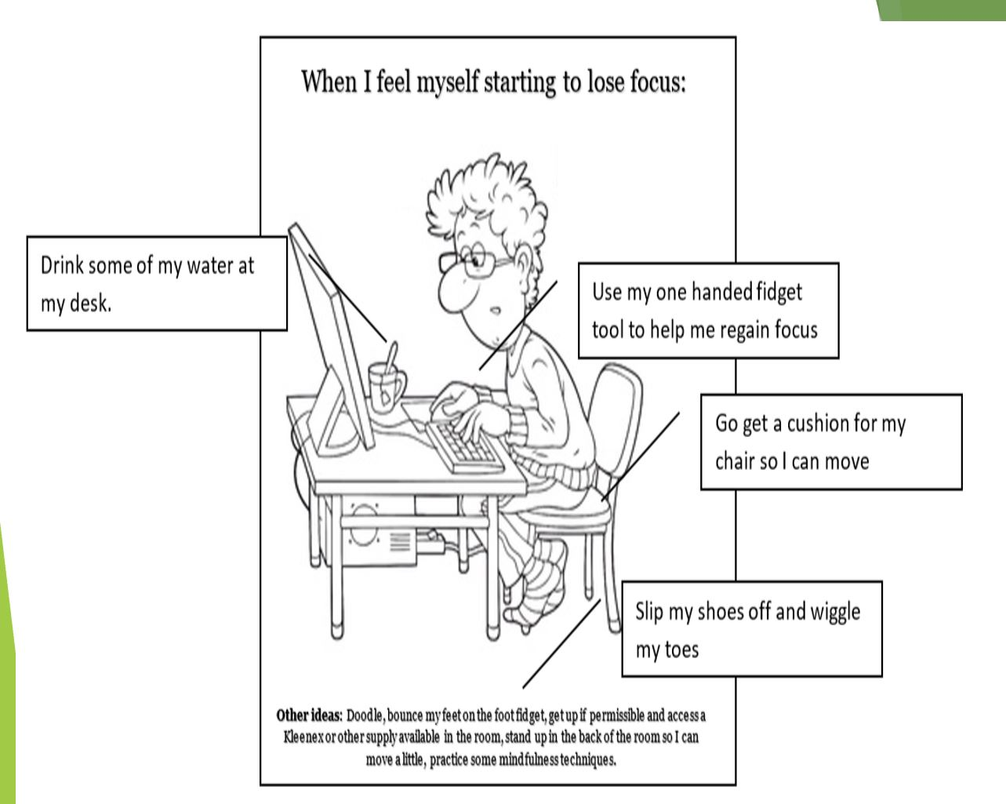
Instead of putting a ton of anchor charts around the room that might serve as visual distractors, I prefer students have an anchor chart folder. This can then be individualized, and they can have it at all times. This could be printed 8.5 x 11 sheet size and put in a student’s anchor chart folder.

Cook, Clayton R.; Fiat, Aria; Larson, Madeline; Daikos, Christopher; Slemrod, Tal; Holland, Elizabeth A.; Thayer, Andrew J.; Renshaw, Tyler – Journal of Positive Behavior Interventions, 2018

